This application is a AR application made for mobile devices, especially the S21+, made originally in unity. It is a AR portfolio showing off my previous works.

The image targets can be downloaded here:

<https://drive.google.com/drive/folders/1F_6Jloj4zsS7tj3VNubg0NPQOrIJB_AI?usp=sharing>

The scene used for the application is called scene for final

The scripts in use are:

Extra functions

It is used for extra functions in the game, such as to quit the application, to cause the robot fight event on trigger

Music Slider

It is used to adjust the music in the game

Music Script

It is to handle all the songs and noise affects played in the game

Camera Controller

To toggle the camera off and on

All the assets are created by me, except for the music

Music credits:

<https://www.sounds-resource.com/ds_dsi/phoenixwrightaceattorney/sound/5335/>

<https://youtu.be/nyeM6Kywxp0?si=pAmBxPu8i00uDRm_>

<https://youtu.be/c7rywnWMLyc?si=BgPvYMFcuEPcdrYW>

<https://youtu.be/HK2VLhbSaoc?si=3BdtM_ATzoJnPv0A>

Font credit:

<https://eng.m.fontke.com/font/23392034/>

Walkthrough

When booting up the app

You get on the front page

This is the quit button to send you to the quit page

This is the audio button to open the audio page

This is the start button, this is to start the portfolio experience

This is the Audio page where you can adjust the audio by moving the slider

This is the quit panel, pressing yes makes you leave the application, clicking no goes back to the start page

This is the introduction page where I introduce myself and explain why I have a quiz section, it is so those who are using the app can learn more about me through the quiz

When clicking on next you go onto the first question asking which school I am from

The correct option for the first qn is option1

When you get the answer right you will get this response

When you get the wrong answer you will get this response

This is the second question

The answer to the second question is the forth option

This is the third and final question

The correct answer is the third option

After this you will be congratulated and finish the quiz, where the character will explain what’s going to happen next

Next is an explanation panel to explain what to do and if you click on the ? button when you are lost it will inform you on what to do again if you are confused

This is the toggle button to turn on and off the camera

To go back to the front page, click on this button

You must show one of the image targets and click the button to start to see one category of work ive done ( for example what it will look like )

3d Works

When you click the button it shows an explanation of whats shown on screen for example this is a crystal ive done, click on the screen to summon the model

Next is showing a prefab ive done with the use of trim sheets

Next is the iron giant,

if you drag the iron giant to one side and go onto the next panel, you will see another robot ive done

in the past, when dragging the iron giant towards the second robot, it will start a fight between the robots

Digital Designs

First thing shown is the cards ive made in the past

Second thing shown is a clown promotional banner art ive done which ive integrated into AR in Aero

Model sheet

App

Cute things

Coding projects

First thing shown is an adventure game ive done in the past

Followed by a visual novel game ive done

A website ive coded

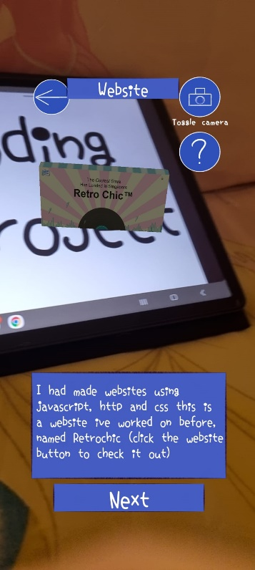

And a python game ive done in the past

